|  |  |  |  |
| --- | --- | --- | --- |
| **Lyng Primary School Knowledge Organiser** | | | |
| **Topic:** | **WWII Human and Physical Geography**  **Would you like to live in the countryside?** | Year 4  Battles, beliefs and buildings | Summer |



**Background information for parents and teachers.**

On the night of 14th November 1940, the Luftwaffe (German bombers) attacked Coventry. The bombing of Coventry was seen as the biggest test of British resolve up to this stage of the Blitz (German raids). Known as ‘Operation Moonlight Sonata’, over 400 bombers attacked Coventry that night and in the early morning of 15th November 1940.

Coventry was an important engineering and manufacturing city before World War Two and the factories based there played an important part in supplying Britain’s military in the early months of the war. Many of the workforce within the city lived very near to the factory they worked at, so any attack on the factories was bound to hit homes as well.

The German’s plan was to create a firestorm within the city that would destroy factories and totally break the morale of the people there. The aim of the attack was to create such a feeling of shock and despair.

By the time the attack was over, 75% of all buildings in the city were destroyed; 33% of all factories were destroyed and 50% of all homes. Most people had to exist without water, gas or electricity.

|  |  |
| --- | --- |
| **What Step On and Goldilocks words will I use?** | |
| **Spelling** | **Definition** |
| Air raid | An attack by planes dropping bombs |
| Air raid shelter | A building to protect people from bombs |
| Allies | Countries (including Britain, France, the Soviet Union and the USA) who joined forces to fight the Axis Powers |
| Allotment | Small plot of land for growing vegetables |
| Axis power | Germany, Japan, Italy and other countries that were allies in World War 2 |
| Blackout | Wartime ban on street lights and other lights at night. |
| Blitz | German air raids, from a German word 'blitzkrieg' which means 'lightning war'. |
| Cathedral | the principal church of a diocese, with which the bishop is officially associated |
| Coventry | Coventry is a city in central England. It’s known for the medieval Coventry Cathedral, which was left in ruins after a WWII bombing. A 20th-century replacement, with abstract stained glass, stands beside it. |
| Evacuee | Someone who was evacuated, moved from a danger area to a safer place. |
| Factory | Places where things are made |
| Host family | People who took evacuees in. |
| Invaded | Attacked or taken over by an enemy. |
| Luftwaffe | A generic German term for an air force. It was also the official name for the Nazi air force founded in 1935. Led by Hermann Goering, it became the largest and most powerful in Europe by the start of World War Two. |
| Nazi | Short for National Socialist Party (in Germany), a follower of Hitler was also called a Nazi. |
| Refugee | A person forced to leave their home, often by war. |

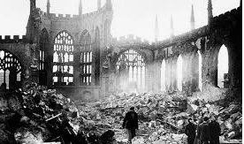

**Fieldwork Opportunities**

Coventry Cathedral-

A tour around Coventry and a talk inside the Cathedral to get an inside into WW2.

|  |
| --- |
| **Geographical study** |
| Ask and answer geographical questions about the physical and human characteristics of a location.  Explain own views about a location, giving reasons.  Use maps, atlases and globes to locate countries and describe features. Describe the geographical similarities and difference between countries.  Name and locate counties and cities of the United  Kingdom.  Describe geographical similarities and differences between countries.  Use fieldwork to observe and record the human and physical features in the local area using a range of methods including sketch maps, plans and graphs and digital technologies |

**Significant places**

* Germany
* England
* Coventry
* France
* Japan
* Poland
* Italy
* USA
* Soviet Union (Russia)

**Our Storytelling Approach to enhance engagement**

|  |  |  |
| --- | --- | --- |
| **People:**  Evacuees during WW2 | **Place:**  Coventry, Birmingham | **Problem:**  Our home has just been destroyed by German bombers. |

**Map to be studied**

**Key facts and locations**

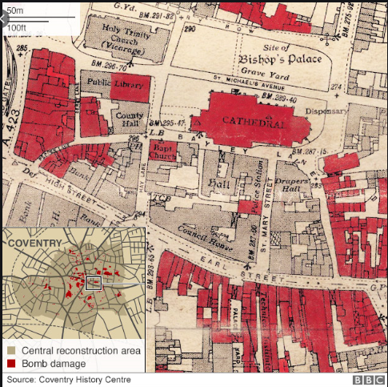

**Agreed Outcome**

To understand the cause and effect of WW2 on Coventry and the wider world.

* The aid raid on Coventry on the night of 14 November 1940 was the single most concentrated attack on a British city in the Second World War.
* Following the raid, Nazi propagandists coined a new word in Germany - Coventrieren - to raze a city to the ground.
* Codenamed 'Moonlight Sonata', the raid lasted for 11 hours and involved nearly 500 Luftwaffe bombers, gathered from airfields all over occupied Europe.
* The aim was to knock out Coventry as a major centre for war production. It was said too, that Hitler ordered the raid as revenge  on an RAF attack on Munich.
* The Luftwaffe dropped 500 tons of high explosive, 30,000 incendiaries and 50 landmines. It was also trying out a new weapon, the exploding incendiary.
* Coventry lost not only its great mediaeval church of St Michael's, the only English Cathedral to be destroyed in the Second World War but its central library and market hall, hundreds of shops and public building and 16th century Palace Yard, where James II had once held court.
* The smell and heat of the burning city reached into the cockpits of the German bombers, 6,000 feet above.
* More than 43,000 homes, just over half the city's housing stock, were damaged or destroyed in the raid.
* King George VI is said to have wept as he stood in the ruins of the burned out Cathedral, surveying the destruction.
* The people of the city were traumatised. Hundreds wandered to the streets in a daze and little children were seen trying to burrow their way through solid brick walls to escape the terrifying noise.
* The official death toll from the night was 554, but the real figure could have been much higher with many people unaccounted for.
* In 1947, Coventry had adopted its first German twin city, Kiel. Dresden followed in 1956.
* The ruined Cathedral now stands for international peace and reconciliation.

|  |  |  |  |
| --- | --- | --- | --- |
| **Lyng Primary School Knowledge Organiser** | | | |
| **Topic:** | **WWII**  **Human and Physical Geography** | Year 4  *Battles, Beliefs and Buildings* | Summer |

|  |  |  |
| --- | --- | --- |
| 5. Name 3 countries that fought with the Allies against Nazi Germany. | **S** | **E** |
| 1. |  |  |
| 2. |  |  |
| 3. |  |  |

|  |  |  |
| --- | --- | --- |
| 6. When did German bombers attack Coventry? | **S** | **E** |
| 1. 1st September 1939 |  |  |
| 1. 14th November 1940 |  |  |
| 1. 14th April 1947 |  |  |

|  |  |  |
| --- | --- | --- |
| 7. Define ‘Luftwaffe’ | **S** | **E** |
| ______________________________________ ______________________________________ ______________________________________ |  |  |

|  |  |  |
| --- | --- | --- |
| 8. What did the city of Coventry produce before they were bombed? | **S** | **E** |
| 1. Masses of food for rationing |  |  |
| 1. Important engineering and manufacturing for military |  |  |
| 1. German bombs |  |  |

|  |  |  |
| --- | --- | --- |
| 1. Where in England is Coventry located? | **S** | **E** |
| 1. East Midlands |  |  |
| 1. West Midlands |  |  |
| 1. London |  |  |

|  |  |  |
| --- | --- | --- |
| 2. Who ruled the British Empire? | **S** | **E** |
| 1. King Albert |  |  |
| 1. Queen Victoria |  |  |
| 1. Thomas Barnardo |  |  |

|  |  |  |
| --- | --- | --- |
| 3. What was the effect of the Luftwaffe bombing Coventry? | **S** | **E** |
| ______________________________________ ______________________________________ |  |  |

|  |  |  |
| --- | --- | --- |
| 4. List 3 reasons why German bombed the city of Coventry. | **S** | **E** |
| 1. |  |  |
| 2. |  |  |
| 3. |  |  |